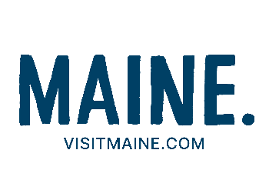

MAINE OFFICE OF TOURISM

**PRESS TRIP REQUEST FORM**

**We are pleased to consider your request for a media visit. You are asked to fill out the form below that will help us assess your needs for your visit to Maine. The following guidelines are important to note as you prepare your request:**

1. **We require six weeks in which to plan and arrange your trip.**
2. **July and August media visits are extremely difficult to accommodate and are limited during this period.**
3. **The Maine Office of Tourism does not cover transportation costs to Maine.**
4. **This form is used for press/influencer visits that are handled like press trips. All paid partnership requests will be turned over to Maine’s ad agency.**

*We make every effort to provide accommodations at either a complimentary or reduced rate. However, it is not always possible to reserve such rates during peak periods and weekends throughout the year*.

*Meals are not provided unless specified on the itinerary. All incidental expenses are borne by the individual. Expenses for accompanying family/friends are not covered.*

**Please return the form to** [**tourism@marshallpr.com**](mailto:tourism@marshallpr.com)**.**

**Name: Date:**

**Email / Phone / Mobile phone while traveling:**

**Mailing address:**

**Requested dates of travel:**

**Number in group / Name(s)**

**If children are traveling, please list ages:**

**Number of rooms and beds required:**

**Outlets / Affiliations (For personal blogs, please attach a screen shot of their analytics page including UVM, pageviews and bounce rate):**

**Links to recently published articles:**

**Social media handles and reach:**

**Approximate date of publication:**

**Do you speak English?**

**Special dietary requirements:**

**Special accessibility/mobility needs:**

**Allergy or health considerations:**

**Which region or regions of Maine are of interest:**

**Desired activities:**

**Please list all assistance you are requesting** **(examples: hotels, meals, contacts, guides, etc.):**